# Power Edge Wiring Configuration

## PR710

PR710 Owners Manual Pages 19-20

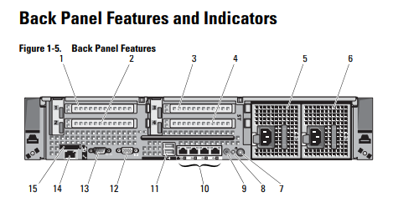

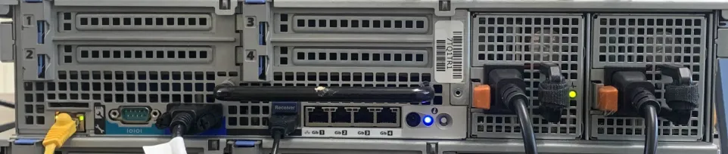

**Port 5/6 -** Power Suppy. E161C and E1620 may appear as a System message. Please consult owners manual Table 1-1 System Status Messages.

**Port 11 -** Mouse & Keyboard

**Port 12 -** VGA Display.

**Port 14 -** iDRAC ethernet port, this will need to be connect to the LAN port. For more information on iDRAC, read the following document. [iDRAC Port: Elevate Your Server Management with Seamless Remote Access](https://1gbits.com/blog/understanding-idrac-port/)

## 

## PR730

PR730 Owners Manual Pages 15-16

